Objectives

- Explain React State

In this hands-on lab, you will learn how to:
- Use React State object

Prerequisites

The following is required to complete this hands-on lab:
- Node.js
- NPM
- Visual Studio Code

Notes

Estimated time to complete this lab: 60 minutes.
Create a React App “counterapp” which will have a component named “CountPeople” which will have 2 methods.

UpdateEntry() which will display the number of people who entered the mall.
UpdateExit() which will display the number of people who exited the mall.

Use Constructor and state to Store the entrycount and exitcount.

The component has 2 buttons
- Login when clicked, the entrycount should get incremented by 1
- Exit when clicked, the exitcount should get incremented by 1

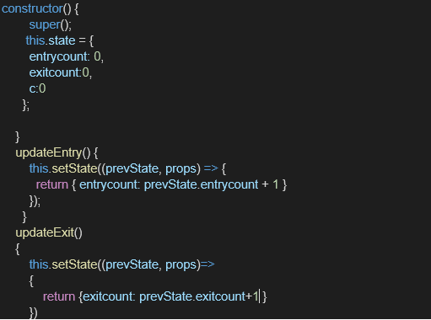

The output should be as follows:

